### Airbnb Dynamic Pricing Recommendation Engine

### Project by: Varsha Sharma

Average Price by City

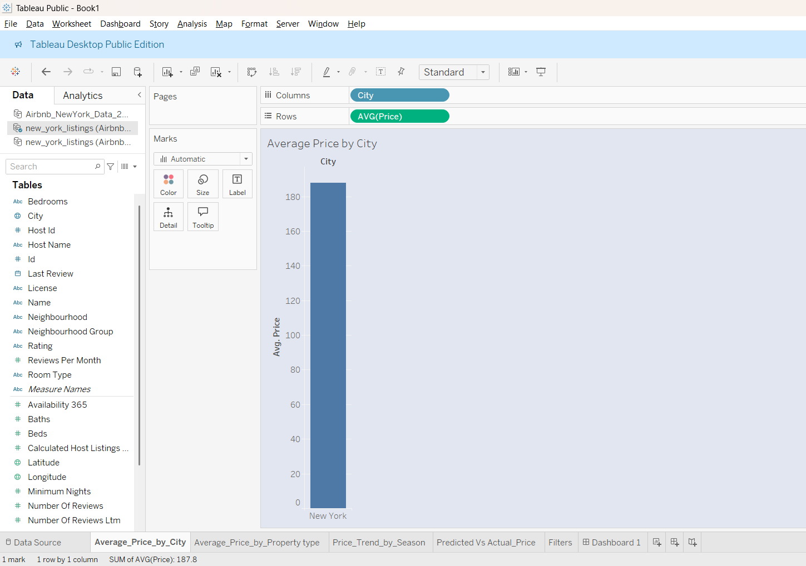

Average price by Property

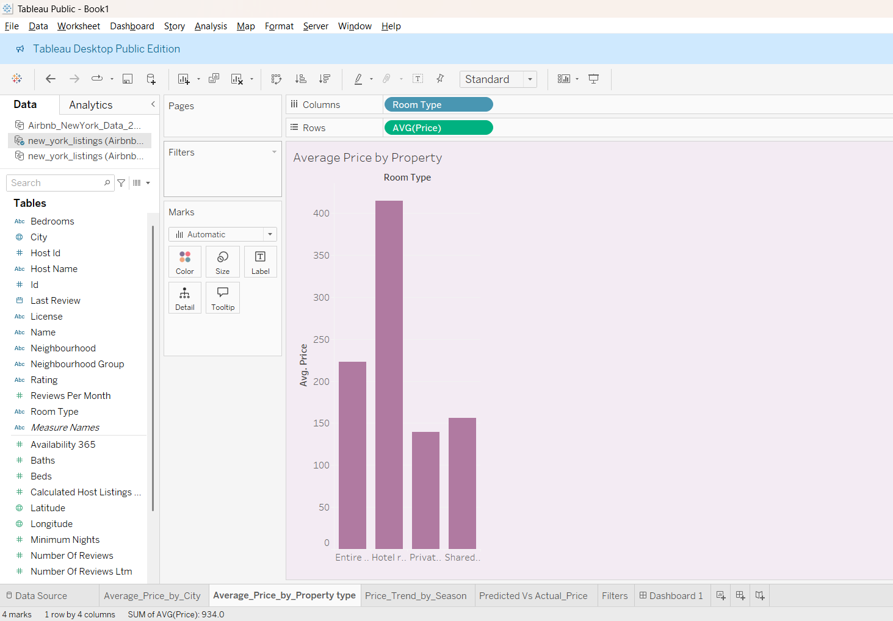

Price Trend by Season

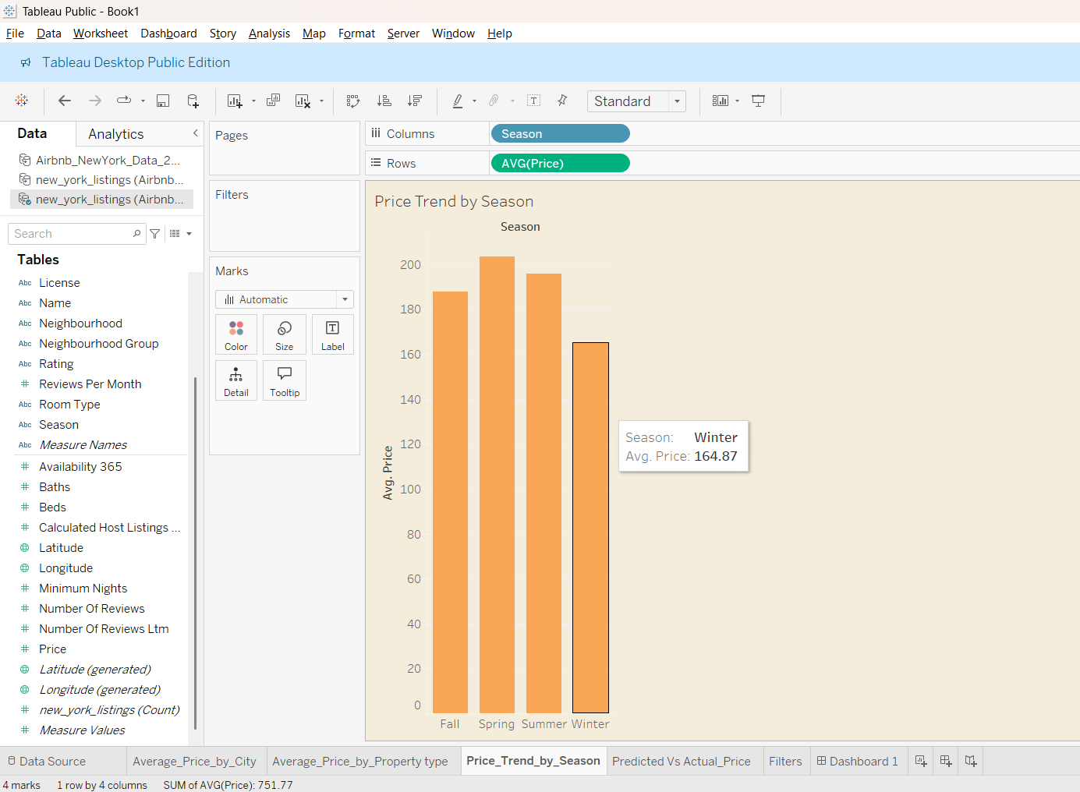

Predicted Vs Actual Price

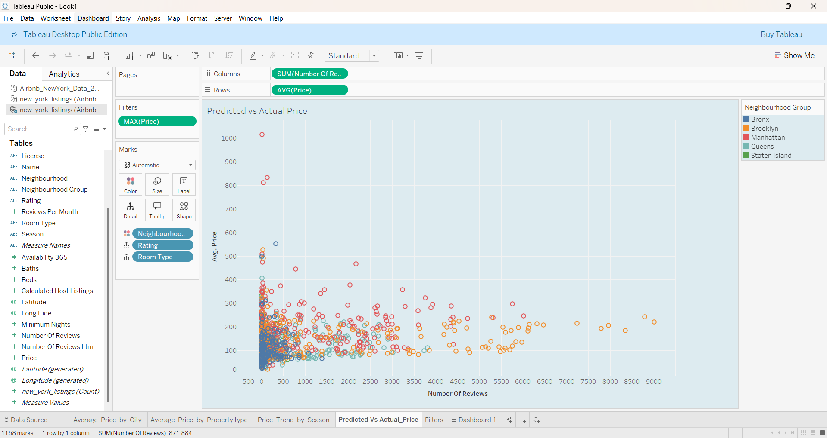

Filters

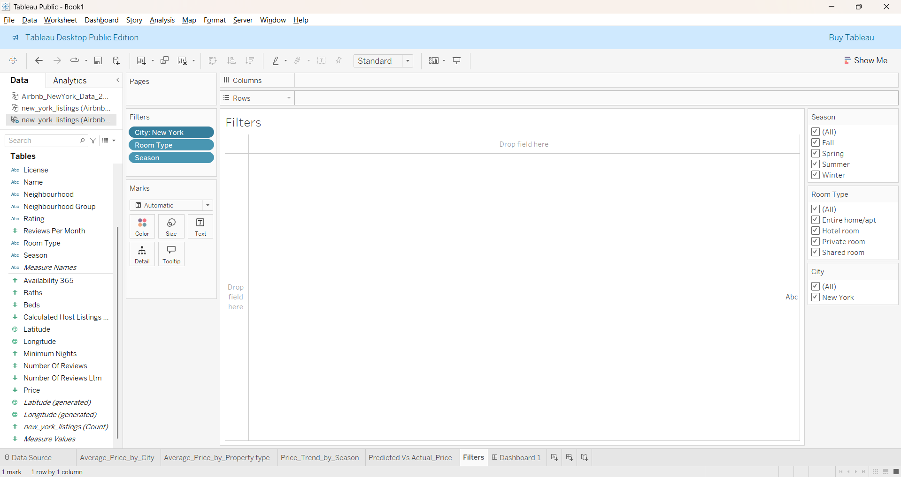

Airbnb Dashboard with Filters

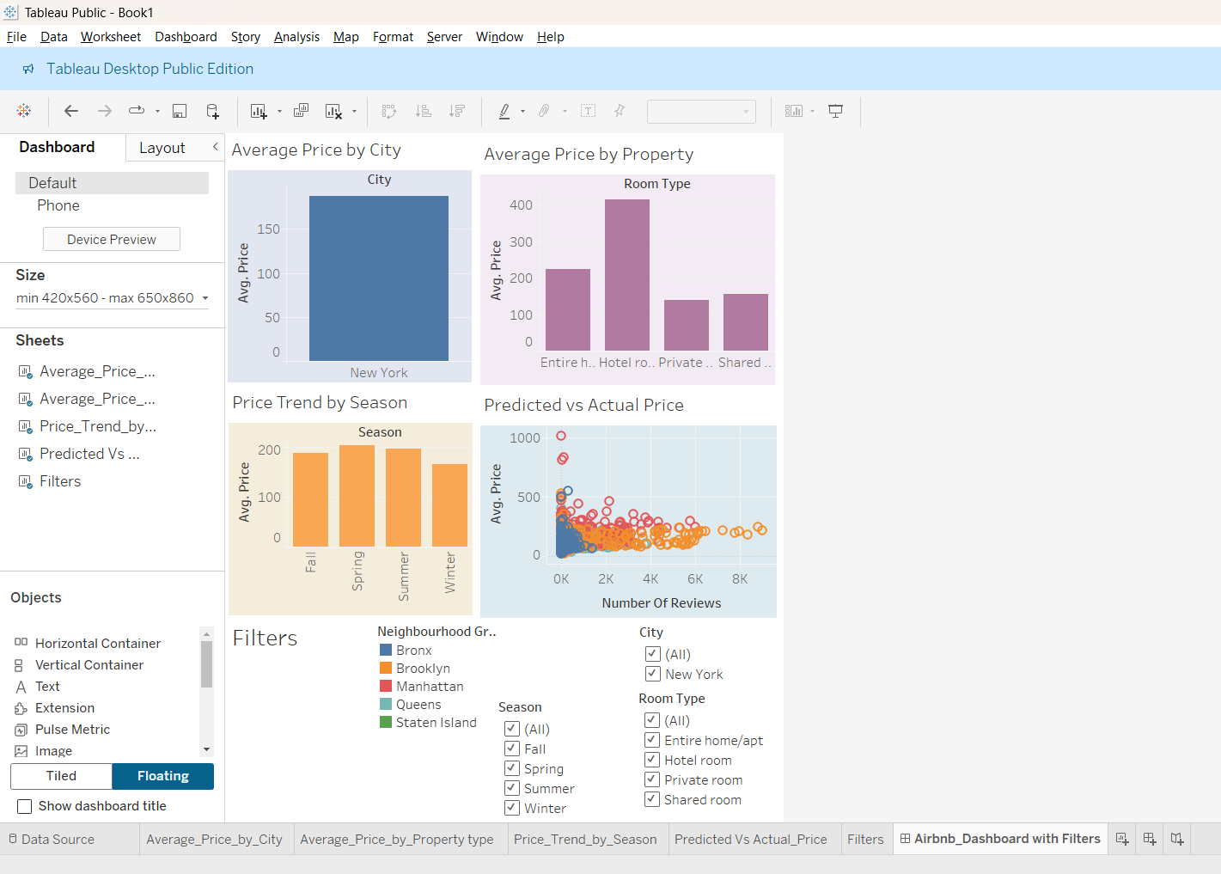

**Airbnb Dynamic Pricing Recommendation Engine**

**Introduction**

Accurately pricing each listing is essential for hosts to stay competitive and optimize occupancy as Airbnb becomes a global hotel substitute. This project's goal is to use historical New York Airbnb data to create a data-driven pricing recommendation system. By studying trends in seasonality, property type, and reviews, we give insights and predictive tools to assist improve listing prices. The project combines analytical techniques and visualization tools to help hosts make informed pricing decisions. By identifying key pricing factors, this solution empowers hosts to attract more bookings while maximizing revenue potential.

**Abstract**

This project combines Python, Excel, and Tableau to analyze Airbnb listings and develop a pricing engine that predicts optimal listing prices. Using regression modelling, we identify the most influential variables affecting price. An interactive Tableau dashboard supports decision-making with visual insights, while the final report consolidates our methodology and results. The approach not only highlights pricing trends across different property types and seasons but also enables hosts to test different scenarios using dynamic filters. This comprehensive solution helps bridge the gap between raw data and actionable pricing strategies.

**Tools Used**

* **Python**: Data preprocessing and price prediction using linear regression.
* **Excel**: Data cleaning, column creation (e.g., Season, City), basic analysis.
* **Tableau**: Dashboard creation with filters, charts, and price sliders for user interaction.

**Steps Involved**

**1. Data Cleaning (Excel)**

* Removed empty/missing rows.
* Added columns: City, Season, Property Type, Predicted Price.
* Converted date formats to derive months and seasonal tags.

**2. Data Analysis & Modeling (Python)**

* Analysed price trends by room type, neighbourhood, and review count.
* Built a linear regression model using room type, number_of_reviews, and neighbourhood group as predictors.
* Compared predicted vs. actual prices to validate the model.

**3. Dashboard Creation (Tableau)**

* Imported the cleaned dataset and added filters: Room Type, Neighbourhood Group, Season.
* Created visualizations: bar charts (avg. price by city), scatter plots (reviews vs. price), and a price suggestion slider.
* Enabled interactive exploration of price ranges and trends.

**Conclusion**

The project effectively demonstrates the power of data analytics in solving real-world business problems. The Python-based model identifies pricing drivers, while the Tableau dashboard helps hosts and analysts make informed pricing decisions. With seasonal awareness and dynamic suggestions, this system can increase competitiveness and revenue for Airbnb hosts. Additionally, the inclusion of interactive features guarantees the solution is user-friendly and adaptable for varied company demands. Users can investigate pricing trends by neighbourhood, property type, and seasonality by utilizing real-time filters. Because of this, the model is useful to non-technical users in addition to being functional. All things considered, the research demonstrates how the hospitality sector can make more informed decisions by fusing visual storytelling with predictive modeling.

**Deliverables**

| **Item** | **Description** |
| --- | --- |
| ✅ Tableau Dashboard | Interactive tool with price filters and visual insights. |
| ✅ Python Script | Regression model to predict listing prices. |
| ✅ PDF Report (this) | Summary of methodology, tools, and outcomes. |



Elevate Labs